1.Install MySQL Community Server on your computer and take a screenshot of the MySQL installer completion window.

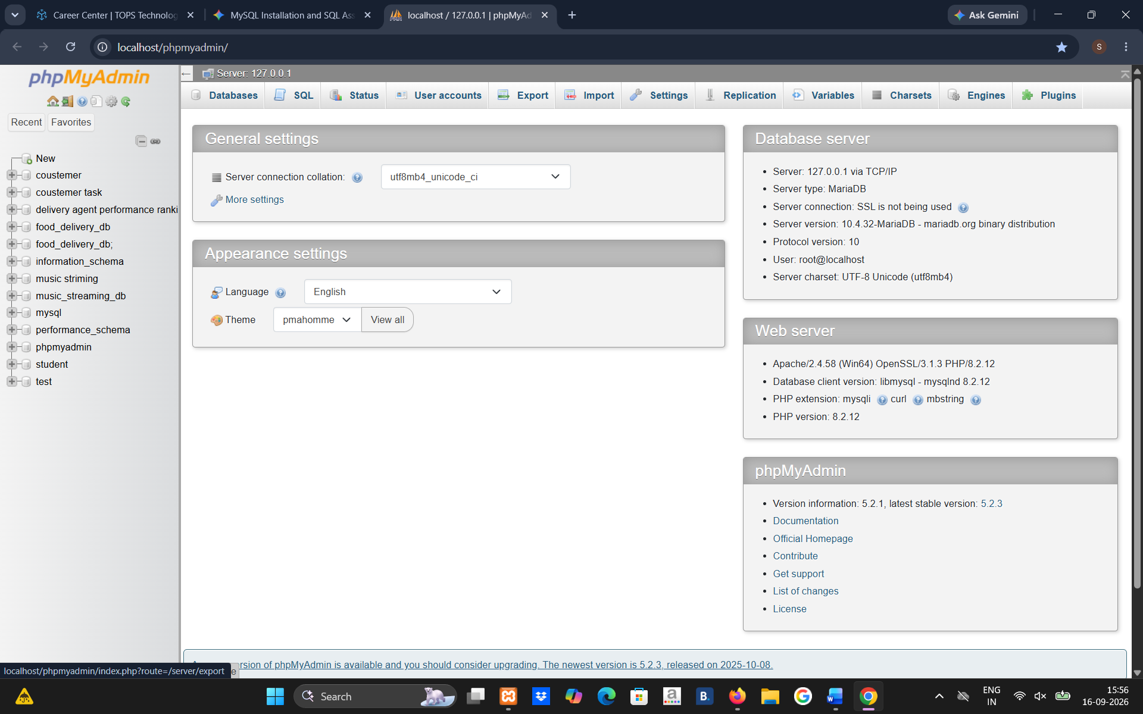

2.Open MySQL Workbench or DB Browser, connect to your local MySQL server, and create a new database called music_streaming_db
Ans ;
Sql;
CREATE DATABASE music_streaming_db;

3.Write the SQL command to create a new database named food_delivery_db and execute it in your SQL Workbench or DB Browser.<br><br><em><strong>Hint:</strong> Use the CREATE DATABASE statement.</em>
Ans;
Sql
CREATE DATABASE food_delivery_db;

4.List 3 differences between MySQL and PostgreSQL in terms of features or use cases, and give one example of a popular app or company that uses each.

Feature / Use Case | MySQL | PostgreSQL
1. Performance & use case | Often preferred for web applications where fast read performance and simplicity are important. | Strong for complex queries, analytics, and data-heavy applications.
2. Advanced features | Supports common SQL features and is generally simpler to configure and use. | Offers more advanced features such as custom data types, arrays, JSON/JSONB, and powerful indexing.
3. Extensibility | More focused on standard relational database use cases. | Highly extensible, allowing custom functions, operators, data types, and extensions

